Siddhanta Shiromani
Grahaganit adhyaya
Chandragrahanaadhikar
(Section III, Chapter 3 : Lunar Eclipse)

Verse No | Translations
1 | Scholars of Smritis and Puranas declare that prayer, charity or offerings to gods made in fire at the moment of an eclipse conduce to much spirituality. Hence I give hereunder the methods of computing the moments of a eclipse (lunar or solar) which stimulates much interest amongst interested persons.
2 | To know the occurrence of a solar eclipse, find the exact moment of the new moon agreeing in degrees, minutes and seconds. Likewise to know the occurrence of a lunar eclipse compute the exact moment of the full moon agreeing in degrees, minutes and seconds. Also compute the longitude of the Rahu for the moment as directed.
3 | The distance of the centre of the globe of the Sun is 689,377 Yojanas and the distance of the centre of the globe of the Moon is 51,566 Yojanas, both being measured from the centre of the earth. This is called the Grahakakshabyasaardha (half of the distance of the orbit) or Karna.
4 | The radius vector is to be computed even in the case of Equation of Centre as we did in the case of Sighrafala. If that be denoted by ‘k’ then the corrected Kalaakarna (half of the distance of the orbit in minutes) for both sun and the moon would be given by the fraction :  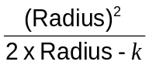
5 | The half of the distance of the orbit in Yojanas (Yojanakarna) be multiplied by this Kalaakarna and divided by the radius we will have the rectified Yojanakarna.  The spherical diameters of sun is 6522 Yojanas and that of Moon is 480 Yojanas.
6 | 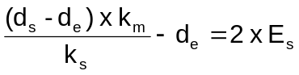  Where  d_{e} = Earth’s diameter  d_{s} = Sun’s diameter  k_{m} = Moon’s distance from Earth’s centre  k_{s} = Sun’s distance from Earth’s centre  E_{s} = radius of earth’s shadow cone at the lunar orbit
7 | The diameters of the Sun, the Moon and the Earth’s Shadow in Yojanas multiplied by the radius and divided respectively by the Karnas of Sun, moon and moon we will have their angular measures.

Verse No | Translations
8 | The daily motion of the sun increased by one tenth of its value and halved, gives the angular diameter of the Sun. Thrice the daily motion of the moon divided by 71, gives the angular diameter of the moon. Alternatively, the moon’s daily motion decreased by 715 and divided by 25 and the result being added to 29 gives the angular diameter of the moon.
9 | During a lunar eclipse the shadow of the earth covers the moon and in case of a solar eclipse the shadow of the moon covers the sun.
10 | The latitude of the moon (β say) or the Vikshepa is given by :  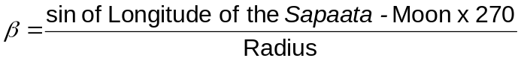  If the longitude of the Sapaata-Moon is less than 6 Rashis (180°) then β is taken to be in the north and if it is greater than 6 Rashis then β is taken to be in the south. This latitude of the moon (β) is also called VaaNa or Shara.
11 | The magnitude of an eclipse (Sthagita) is defined as  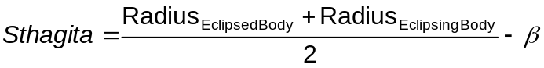  Where β = Latitude of the moon.  The eclipse is total when Sthagita > Radius_{Eclipsed Body} .
12 | The duration of the eclipse (Sthithi-Khanda) and the duration of the totality (Vimarda-Khanda) is given by :  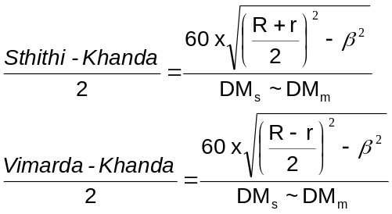  Where R = Radius of the Eclipsing body  r = Radius of Eclipsed body  β = Latitude of the moon  DM_{s} = Daily motion of the Sun  DM_{m} = Daily motion of the Moon
13 | If the half of duration of the eclipse (Sthithi-Khanda) be multiplied individually by their own daily motions and dividing that product by 60 we will have a result. If this result be subtracted from the moon and added to its Node, and then from this the instantaneous latitude of the moon (β) be calculated for the moment of first contact and last contact, we can rectify the time of first contact and last contact from the β using the method of successive approximation.

Verse No | Translations
14 | Proceeding on the same line as above, the half of duration of the totality (Vimarada-Khanda) would be worked upon similarly and the result would then be subtracted from the moon and added to its Node, and then we proceed as described above, we can then rectify time of commencement of the totality and the time of ending of the totality of the eclipse by the method of successive approximation.
15 | The word Ishta would be used to mean ‘at any given time’. The term Sparshika-Ishtakaala would mean ‘at any given time after the moment of first contact’. Similarly the term Maukshika-Ishtakaala would mean ‘at any given time before the moment of last contact’. The method to obtain the Sthithi-Bhuja Kalaa is as follows :
16 | Similarly the Vimarda Bhuja Kalaa can be computed as :  Taking the latitude of moon (β) at any given time as the perpendicular, the Bhuja as the base the hypotenuse (Karna) would be given by :  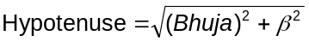
17-18 | The eclipse is given by the formula :  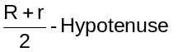  To obtain the time after the moment of first contact given the eclipse (Ishta), at the moment, we use the following formula :  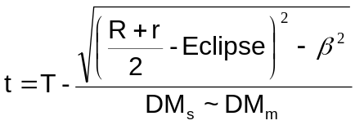  Where t = IshtaTime (Sparshika/Maukshika)  T = Sthithi Kahnda / Vimarda Khanda as the case may be  R = Radius of the Eclipsing body  r = Radius of Eclipsed body  β = Latitude of the moon  DM_{s} = Daily motion of the Sun  DM_{m} = Daily motion of the Moon  This time t is to be rectified by obtaining the β of the moment and again finding the time t and repeating the process till an invariable magnitude is obtained.
19 | The Madhya Grahana (the middle of an eclipse or strictly speaking the moment when the potion eclipsed is maximum) occurs at the moment of opposition. Sparsha is at the moment of first contact and Moksha is at the moment of last contact, separated from the moment of the middle of the eclipse by times equal to Sthithi khanda (called Sparsha-Sthithi-Khanda and Moksha-Sthithi-Khanda respectively) before and after. Similarly Sanmilana (or the moment of the commencement of totality) and Unmilana (or the moment of end of totality) occur before and after the moment of Madhya-Grahana by times equal to Viumarda-khanda (called Sanmilana-Marda-Kahnada and Unmilana-Marda-Khanda) respectively.

Verse No | Translations
20 | The hour angle of the eclipsed body expressed in naris be multiplied by 90 and divided by half the duration of the night. (if it be lunar eclipse) or half the duration of day (if it be solar) as the case may be will give the degrees of an angle, whose sine be multiplied by the sine of latitude and divided by Dyujyaa, gives the sine of Akshavalana which is north when the hour angle is east, and south otherwise.
21 | The cosine of the longitude multiplied by sin 24° divided by the Dyujyaa gives us a result whose arc is defined as Ayanavalana. The direction of this Ayanavalana is that of the hemisphere of north or south in which the Moon lies.
22 | The sine of the sum or difference of the two Valanas according as they are of the same or opposite directions, multiplied by the half of the sum of angular radii of the eclipsing and eclipsed body, and divided by the radius gives the sine of rectivied Valana.
23 | Those who say that this Valana is proportional to the versed sine, do not know the spherical geometry properly.
24 | Determine the Shanku in the method described in the Triprashnadhikara Chapter. Divide this Shanku by the radius and we will have 2½ fingers as a result. The time elapsed after the rise of the body being divided by the hour angle (both being expressed in units of time) gives us the same 2½ finger result.
25 | The measures of Valana, Shara, Channa or the part shadowed, the celestial latitude of moon or eclipsing body, Disc, Bhuja, perpendicular and hypotenuse can be converted to finger measure using the above formula. While drawing a figure for solar eclipse the Shara would be in the same direction, for the lunar eclipse it should be drawn in the opposite direction.
26-29 | Draw a circle with radius equal to that of the radius of the disc of the eclipsed body and also a circle of radius equal to the sum of the radii of the eclipsed and eclipsing body. Mark the directions (N-E-S-W etc) on the figure. In the half of the outer circle show the Valana and mark the Sparsha of the moon from the east point on it and also mark the Moksha on it from the west point. For Sun the reverse has to be done, that is, Sparsha from the West point and Moksha from the east point. If the latitude is south then from the south point else if the latitrude is in the north then from the north point determine the mean Valana. From the south Valana, the Valana should be marked clockwise (E To S to W to N, or in the Savya Krama) like a chord, or it should be marked anticlockwise (or in the Upasavya Krama). After this draw the lines from the centre to the extremity of the Valana. From the extremity of the Sparsha Valana draw the Sparsha latitude, and similarly from the extremity of the Moksha Valana draw the Moksha latitude like chords to a circle. Determine the mean latitude taking the middle point of the centre and the extremity of the Valana. Taking the extremities of these latitudes, circles are to be drawn with the radius of the eclipsing body to depict the eclipse at the respective moments (Sparsha, Mukti and Madhya Graasa).
30 | The Bhuja is to be laid from the centre of the moon along the line indicating the direction of the ecliptic. The latitude is to be drawn from the end of the Bhuja and perpendicular to Bhuja. The Hypotenuse is to be drawn from the centre of the moon. Taking the point of intersection of the latitude and the hypotenuse, as centre and radius equal to that of the eclipsing body, if circles are drawn, from these circles, the points where totality begins or ends, as well as the magnitude of the eclipse at any given moment could be known. These could be found in another way as follows.

Verse No | Translations
31-32 | Joining the upper end of the latitude of the middle moment of the eclipse to the first contact we have the Pragraha Marga (Path of the centre of eclipsing body from the first contact to the middle moment of eclipse) and joining the upper end of the latitude of the middle moment of the eclipse to the last contact we have the Moksha Marga (Path of the centre of eclipsing body from the middle moment of eclipse to the last contact). The lengths of these paths could be computed and they could be drawn before hand. Now with the centre of moon as centre and the difference of the diameter of eclipsing and eclipsed body as radius if we draw a circle it would cut the above paths each in one point. With those points as centre and radii equal to the eclipsing body if we draw circles they will touch the moon’s disc each in one point which are respectively Sanmilana and Unmilana points.
33-34 | Let the product of time elapsed from the moment of first contact and the length of the path of the eclipsing body traced from the moment of first contact to the middle of the eclipse divided by the time between the moment of first contact and the middle of the eclipse be x. Similarly, let the product of time before the last contact and the length of the path of the eclipsing body traced between the moment of middle of the eclipse and the moment last contact divided by the time between the middle moment and the moment of last contact be y. Lay off x and y units of length from the first and last points of the path of the eclipsing body along the path respectively. Then we get the points of centre of the eclipsing body at the required moments. With these points as centre and radius of eclipsing body as the radius if circles be drawn they represent the eclipsing body. The length of the diameter of the eclipsed body gives the magnitude of the eclipse. This method is described in detail so that everybody could understand it.
35 | Subtract the magnitude of eclipse from the half of the sum of radii of eclipsed and eclipsing body. Take this as the radius and draw a circle. This circle traces out two paths on the outside of the circle. These two path segments when multiplied by their own half of Sthithi-khanda and divided by the length of the paths described above (in fingers) gives us the time elapsed after the moment of first contact or the time before the last contact.
36 | In case of lunar eclipse, if the part shadowed (Channa) be less then the moon would be seen smoke coloured (i.e. grey); if the part shadowed be half then the moon would be seen black coloured; if the part shadowed be more than half then the moon would be seen blackish-red coloured and if the part shadowed be complete then the moon would be seen reddish-brown coloured. For Solar eclipse however, what ever may be the part shadowed, it is always black coloured.
37 | When even one-sixteenth of diameter of the moon’s disc is shadowed the eclipse will not be visible in as much as the shadowed portion is covered by the illuminating rays of the disc. In case of the Sun, when even one-twelfth of the diameter is shadowed, the eclipse will not be visible for same reason. Hence the learned men shall not declare the occurrence of an eclipse upto shadowing of the discs to the extents above.
38 | When the sun is in the Zenith, the ecliptic being vertical, and the Valana is observed to be (λ + 3 Signs) where λ=longitude of the sun, o my friend how will you rectify the Valana using versed sine chart on the basis of the formula given in the Dhi Vriddhi Tantra ?
39 | Where the latitude is 66° (90°-24°; i.e. ^{π}/₂- obliquity of the ecliptic) and the sun being situated in either Aries, Taurus or Aquarius, the moon contacts him from the south at the moment of solar eclipse, as because the ecliptic coincides with the horizon. How in this circumstance could the Valana be equal to the radius as made out by versed sine formula ?
Hence ends the chapter named Chandragrahanaadhikar
of Grahaganita part of Siddhanta Shiromani

Akshavalana = Anglke subtend at the body on the ecliptic by the arc joining the north point of celestial horizon and the north pole of the equator.
Ayanavalana = Angle between the secondaries both to the equator and the ecliptic at the place of the eclipsed body on the ecliptic.

